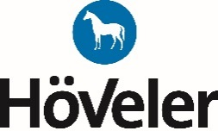
Lista produktów objętych programem Club Card 2018r.

Lp | Kod | Nazwa | Opak. (kg)
1. | 04-1029873 | Aktive | 20
2. | 04-1029864 | All In One | 20
3. | 04-4500285 | EF PferdeMüsli | 20
4. | 04-1029847 | FohlenMüsli | 20
5. | 04-4500286 | Getreide-Mix-Gold | 20
6. | 04-1029869 | KräuterMüsli | 20
7. | 04-1029866 | Oldie-Mix | 20
8. | 04-4808253 | ProBalance | 20
9. | 04-4808282 | PUR.ITAN | 20
10. | 04-1029862 | Reformhafer | 25
11. | 04-4500287 | Reform-Mix | 20
12. | 04-1029874 | Relax | 20
13. | 04-4808275 | Summer | 25
14. | 04-1029863 | terabb E | 25
15. | 04-4808228 | terabb S | 25
16. | 04-4808225 | terabb-A | 25
17. | 04-4808246 | terabb-FS 16 | 25
18. | 04-1029849 | terabb-ZF | 25
19. | 04-4500284 | Vollkorn-D-Mix | 20
20. | 04-4501730 | Wester Basic | 20
21. | 04-4501731 | Western Sport | 20
22. | 04-4808243 | ZF Plus | 20
 | 